**Cross section**

For the cross-section data, Evaluated Nuclear Data File I.e. ENDF are used from ENDF Database. The version is ENDF/B-VIII.0, published in February 2018 in USA. Cross sectional data for the Fuel (UO2), cladding material (Al) and Moderator are obtained from this database. Fission, scattering and capture cross section data were obtained. The energy range for these data starts from 3x10-5 electron volt (eV) to 3x107electron volt. Cross sectional data have been taken by dividing the energy range into equal 13 groups. The total scattering cross sectional data is obtained by finding the values of these different cross-sectional data and adding elastic and inelastic scattering cross sectional values. In order to achieve the cross-sectional data for capture, n,gamma cross section data for these energy groups have been used. The cross section values in barns [10-24 cm2] are converted to cm2 by multiplying by 1e-24. Then these microscopic cross sections are converted into macroscopic cross sections (1/cm) by multiplying them by the number density for each element and material.

Fission cross section, capture cross section and scattering cross section data are plotted for the fuel material:

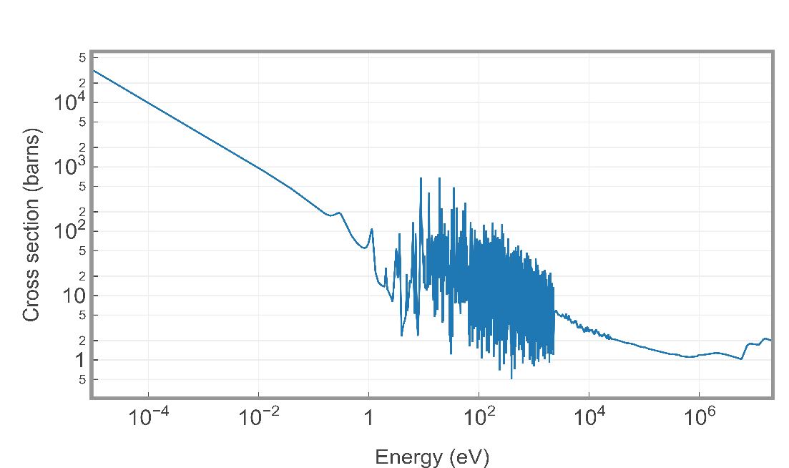

Figure 1: Fission cross section for Fuel

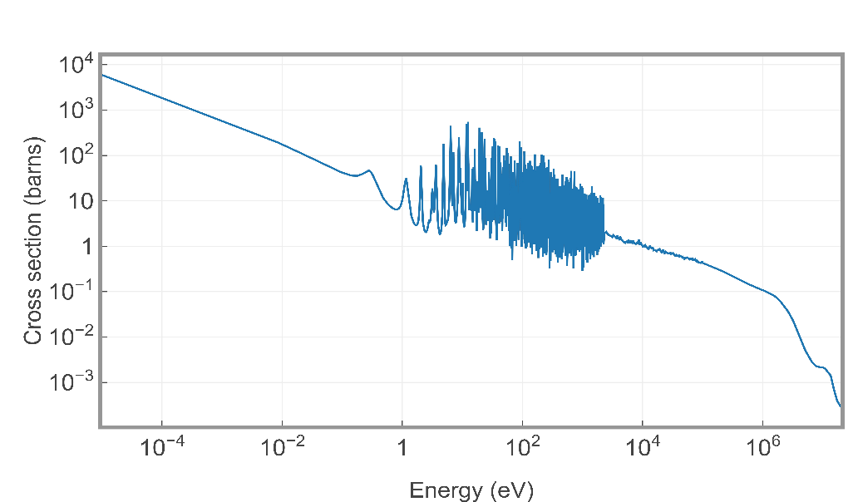

Figure 2: Capture cross section for Fuel

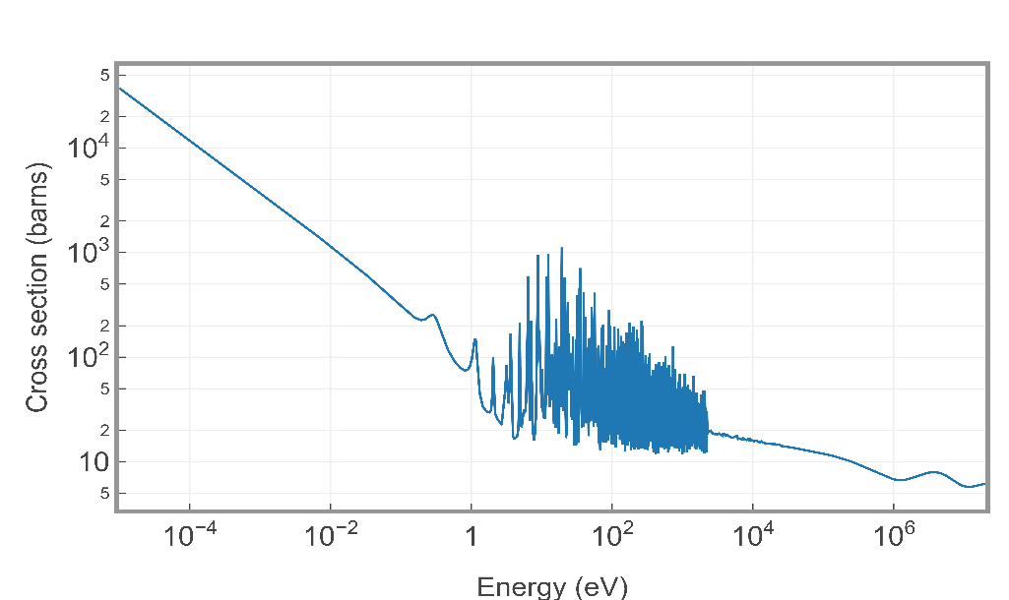

Figure 3: Scattering cross section for Fuel

**Neutron Moderator**

The reactor core is moderated by non-boronised light water. Although neutron collision from elastic scattering can slow down the neutrons, a quicker method that is used is the neutron moderator. It slows down the neutrons going from fission to the thermal energies. The figure below shows how the moderator slows down the neutrons and prevent them from colliding into each other. To have an effective moderator, it is important to have a high elastic scattering cross-section and a high average logarithmic energy decrement.

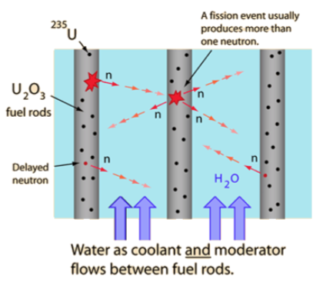

Demonstration of how the neutron moderator works

**Maxwellian-Boltzmann Distribution**

Neutron moderators are mainly used in thermal reactors in which the reactor uses thermal neutrons to sustain the chain reaction. Neutrons in the thermal region achieve thermal equilibrium with the atoms of the moderator. These neutron’s energies are distributed using Maxwellian-Boltzmann distribution which is shown in the equation below, where T is the temperature of the moderator and k is the Boltzmann constant which is $8.52×{10}^{−5}$ eV/K.

$M\left(E\right)=\frac{2πE^{1/2}}{{\left(πkT\right)}^{3/2}}e^{\frac{−E}{kT}}$

The thermal spectrum is defined in the following equation, where $n_{0}$ is the total thermal neutron density.

$ϕ\left(E\right)=n_{0}vM\left(E\right)=\sqrt{\frac{2E}{m}}×n_{0}×\frac{2πE^{1/2}}{{\left(πkT\right)}^{3/2}}e^{\frac{−E}{kT}}$

The figure below graphically shows the thermal spectrum in relation to the rest of the reactor neutron spectrum.

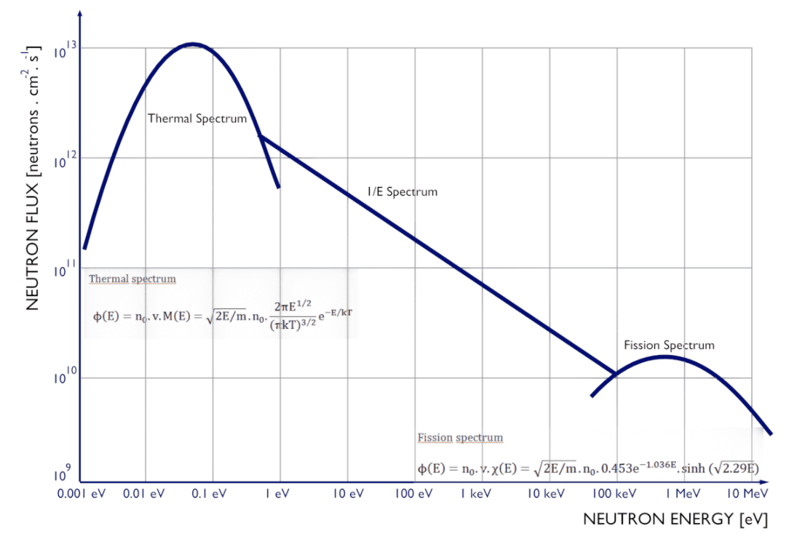

Figure 9: Thermal reactor neutron spectrum

**Geometry and Boundary Conditions**

Qualifying is a transport code and is made to demonstrate criticality calculation for simplified 2D pincell geometry by using Monte Carlo methods for ten group cross sections. Geometry and boundary conditions are shown below.

F

C

M

P

P

P

P

F : Fuel

C : Cladding

M: Moderator

P : Periodic Boundary Condition

rfuel = 0.53 cm

rclad_inner = 0.53 cm

rclad_outer = 0.90 cm

pitch = 1.8 cm

Neutrons are initially distributed uniformly in the fuel region. The fissile content Uranium-dioxide (UO2) is defined as fuel, Aluminum (Al) is defined as cladding material, and water (H2O) as moderator. The energy dependent cross sections of these materials are used for calculations. The periodic boundary condition is applied to pincell boundaries, so neutrons are able to leave the system without doing any interaction and appear at the opposite boundary with same direction. The ultimate purpose of this calculation is to calculate effective multiplication factor (keff) for a specific number of neutrons. The Monte Carlo methods are used to simulate neutron movement and interactions. The initial locations, direction angles and the distance neutron can go before interaction are chosen by random numbers.

**Sampling Initial Neutron Locations**

The initial neutron locations are chosen by using random numbers($ξ$) are between 0 and 1.

To find angular position, theta($θ$) is sampled uniformly over $2π$

$θ=2πξ$

To find radial position, r is sampled over rfuel by considering powerlaw distribution because of radial effect.

$r=r_{fuel}ξ_{powerlaw}$

**Sampling Neutron Direction and Interaction Distance**

The direction angle theta (θ) is sampled uniformly over $2π$. The distance neutron can go before interaction is related to mean free path of a neutron. To sample it correctly, we need to find cumulative distribution function (cdf) from its probability distribution function (pdf) as below,

The probability distribution function of a neutron can be found by using its survival probability.

Neutron Interaction

The survival probability, which is the probability for not being interacted in distance x, is $e^{−Σ_{t}x}$. Then the interaction probability in distance x becomes $Σ_{t}e^{−Σ_{t}x}$

The probability distribution function(pdf) is $pdf\left(x\right)=Σ_{t}e^{−Σ_{t}x}$

Then thecumulative distribution function(cdf) is calculated by integration pdf between 0 and x

$cdf\left(x\right)=\int_{0}^{x}{Σ_{t}e^{−Σ_{t}x^{'}}dx^{'}}=1−e^{−Σ_{t}x}$

Cdf is the distribution function to be used for random numbers to sample interaction length d

$cdf\left(x\right)=ξ=1−e^{−Σ_{t}x}$

Then, the interaction length is sampled by following equation

$d=x=\frac{−1}{Σ_{t}}ln\left(ξ\right)$

**Checking Region Change**

The code stores each neutron position even if it is not interacted, which makes it easy to check whether neutron leaving a region and entering another one. The easiest way to check region change is calculating all distances in neutron direction to all boundaries,and then compare it with the interaction length. If the interaction length is bigger than the closest distance, then the neutron will be moved without being interacted to that surface which has the closest distance.

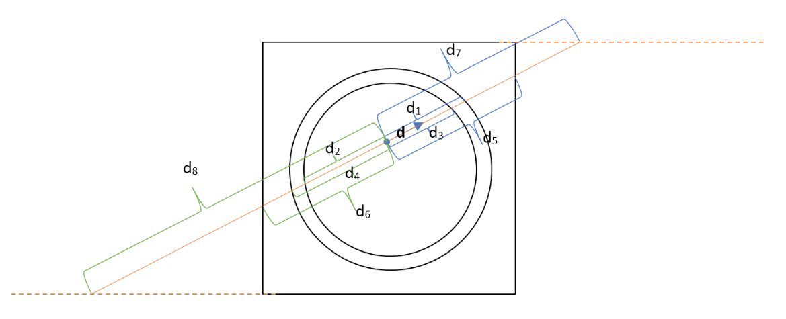

Distances to the boundaries

As can be seen in the above figure, there are 8 different distance value for 8 different intersection. These distances are calculated line equations for circles and boundaries. According to neutron direction, d1, d3, d5, d7 are forward distances and has positive sign. On the other hand d2, d4, d5, d6 are backward distances and has negative sign. Among these distance values, the smallest and positive one will be picked and compared to interaction length d to decide neutron is leaving the region or not. It can be assumed that neutrons are traveling in a line with direction angle $θ$, then the distance values are calculated by using following equations.

For circle surface, the intersection points can be calculated geometrically,

$x^{'}=x+dcosθ$

$y^{'}=y+dsinθ$

${\left(x+dcosθ\right)}^{2}+{\left(y+dsinθ\right)}^{2}=r^{2}$

$x^{2}+2xdcosθ+d^{2}\cos^{2}θ+y^{2}+2ydsinθ+d^{2}\sin^{2}θ=r^{2}$

${\left(sin | 2θ+\cos^{2}θ\right)d}^{2}+\left(2xcosθ+2ysinθ\right)d+\left(x^{2}+y^{2}−r^{2}\right)=0$

$d^{2}+\left(2xcosθ+2ysinθ\right)d+\left(x^{2}+y^{2}−r^{2}\right)=0$

This is quadratic equation with coefficients, $a=1,b=2xcosθ+2ysinθ,c=x^{2}+y^{2}−r^{2}$

$Δ=b^{2}−4ac$

$Δ≥0→∩withthe\overset{˚}{surface}$

$Δ<0→no∩withthe\overset{˚}{surface}$

the roots of this equation are $d_{1}$ and $d_{2}$,

$d_{1,2}=\frac{−b∓\sqrt{Δ}}{2a}=\frac{−b∓\sqrt{b^{2}−4ac}}{2a}$

For right and left boundaries, the intersection points can be calculated geometrically,

$±\frac{pitch}{2}=x+dcosθ$

the roots of this equation are $d_{1}$ and $d_{2}$,

$d_{1,2}=\frac{±\frac{pitch}{2}−x}{cosθ}$

For top and bottom boundaries, the intersection points can be calculated geometrically,

$±\frac{pitch}{2}=y+dsinθ$

the roots of this equation are $d_{1}$ and $d_{2}$,

$d_{1,2}=\frac{±\frac{pitch}{2}−y}{sinθ}$

After comparing the interaction length with the smallest and positive distance, if interaction length is higher than smallest positive distance, then neutron will change the region. The next interaction length must be sampled according to neutronic properties of new region. Neutron is moved to closest surface by using the smallest distance, then x and y coordinates of next neutron location is calculated geometrically and stored. If interaction length is smaller than smallest positive distance, it means neutron is staying in same region and interacting. Neutron is moved to interaction point by using interaction length, then x and y coordinates of interaction location is calculated geometrically and stored.

**Sampling Interaction Type**

Once the neutron interaction length is compared to distances, if there is no region change, the neutron is moved the interaction point and interaction type is sampled corresponding to cross sections. 3 different types of interactions are sampled: Fission, Scattering and Capture.

The cross section data ($Σ_{f},Σ_{c},Σ_{s}$, $Σ_{t}$) is chosen according to neutron energy and region material. The random numbers ($ξ$) are used to decide the interaction type as below,

$Σ_{t}=Σ_{f}+Σ_{c}+Σ_{s}$

$0<ξ<\frac{Σ_{f}}{Σ_{t}}→Neutronundergoesfission$

$\frac{Σ_{f}}{Σ_{t}}<ξ<\frac{Σ_{f}+Σ_{c}}{Σ_{t}}→Neutronundergoescapture$

$\frac{Σ_{f}+Σ_{c}}{Σ_{t}}<ξ<1→Neutronundergoesscattering$

* **Fission**

If fission occurs 2 or 3 neutrons are born with probability of 0.5. The information is stored and the neutron is killed and not being tracked anymore. The simulation continues for new neutron

* **Capture**

If capture occurs, the neutron is killed and not being tracked anymore. The simulation continues for new neutron.

* **Scattering**

If scattering occurs, neutron loses some energy in collision and the direction angle and the interaction length are is sampled again. Neutron is being tracked.

* **Leakage**

If neutron intersects with the boundary, it will disappear at that boundary and counted as leaked, then appear at opposite boundary with same direction angle as incoming neutron from neighbor pincell.

**Calculation of Neutron Flux**

The distribution of the number of neutrons with energy in the fission spectrum is represented by a mathematical function, the Watt function. Thus, the neutron flux function can be represented as

f(E) = B.exp(-E/a) sinh(bE)0.5

**Calculation of Effective Multiplication Factor**

Effective multiplication factor is the ratio of the neutrons produced in one generation to neutrons lost in previous generation.

Neutrons are only produced by fission reaction and lost by leakage and absorption.

$k_{eff}=\frac{NeutronsProduced}{NeutronsLost}$

**Results**

All calculations were run in a HP 2.2 GHz Intel Core i5-5200 using 2000 source neutrons. The neutron flux spectrum calculated by Qualifying is compared with the theoretical flux spectrum calculated based on the Watt function, as shown in the figure below:

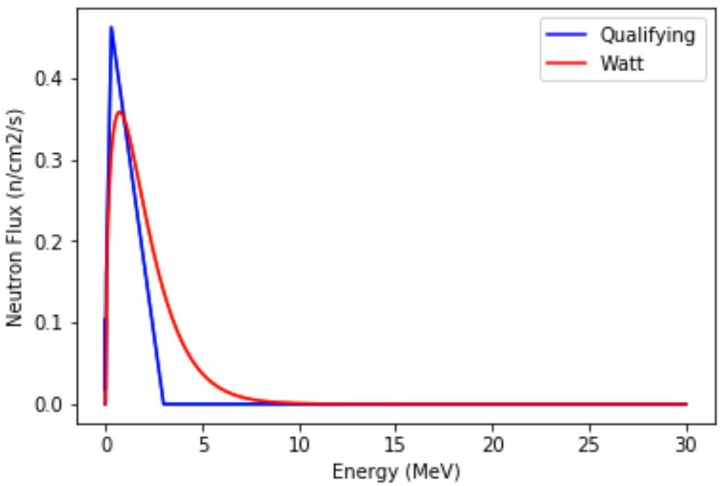

The effective multiplication factor given by Qualifying is compared with other calculations reported in Leppänen 2008. The simulations in Leppänen 2008 were run in a 2.6 GHz AMD Opteron PC using 20000 source neutrons. The results for the critical reference configuration are summarized in the table below.

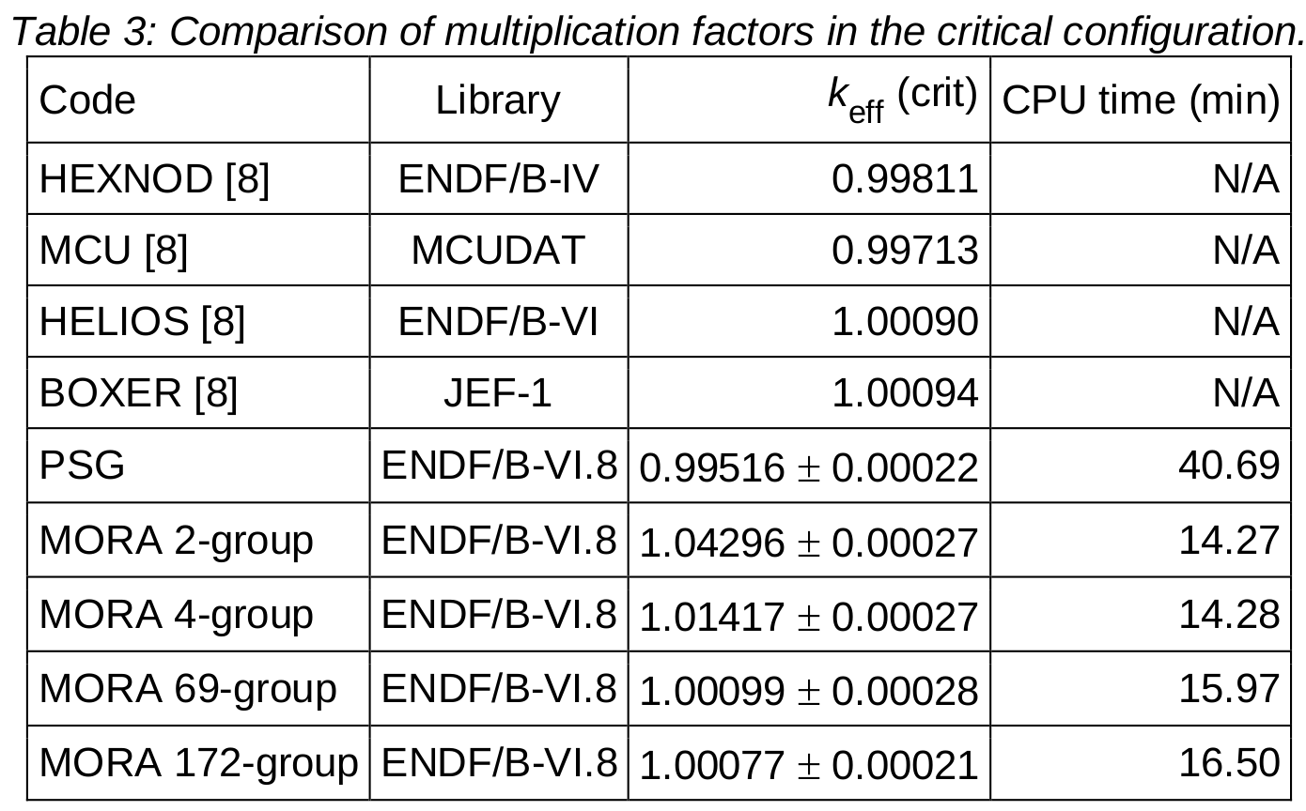

|  |  |  |  |
| --- | --- | --- | --- |
| Qualifying | ENDF/B-VIII | 1.0432 | 240 (2000 neutrons) |

It is shown that the flux spectrum inside the 2D reactor closely follows the pattern predicted by the Watt function, and the effective multiplication factor (keff) given by Qualifying is reasonably close to unity and the reference results. Leppänen 2008 used 20000 source neutrons in their simulation, whereas Qualifying used 2000 due to mechanical constraints. When Qualifying uses higher numbers of source neutrons, the keff values are closer to unity. Furthermore, increasing the energy resolution will result in a more accurate description of the resonance region, resulting in better agreement.